  Copyright © 2024 | Natural Built Social Environment Health  ISSN 3085-461X  www.nbseh.org | 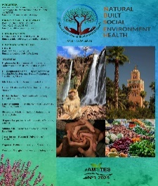
IN MEMORIAM

In Memoriam - Dame Jane Goodall, 1934-2025

This In Memoriam stands as both a reflection and a farewell to Dame Jane Goodall (1934–2025) — naturalist, communicator, and humanitarian. The graphical tribute, bathed in quiet greens and golds, evokes her lifelong harmony with the natural world and her message of hope when the planet seems dark. Goodall was not simply an observer of chimpanzees in Gombe but a reconciler of species, a woman who bridged the emotional distance between human beings and nature. Her gaze, her silence, and her patience became instruments of revelation. We recall her courage to challenge the hierarchies of science, her compassion and her conviction that change begins with daily acts of care. The forest silhouettes and the rising light in the composition mirror the continuity of her work — a reminder that, as she said, “Even when the planet is dark, there still is hope.”

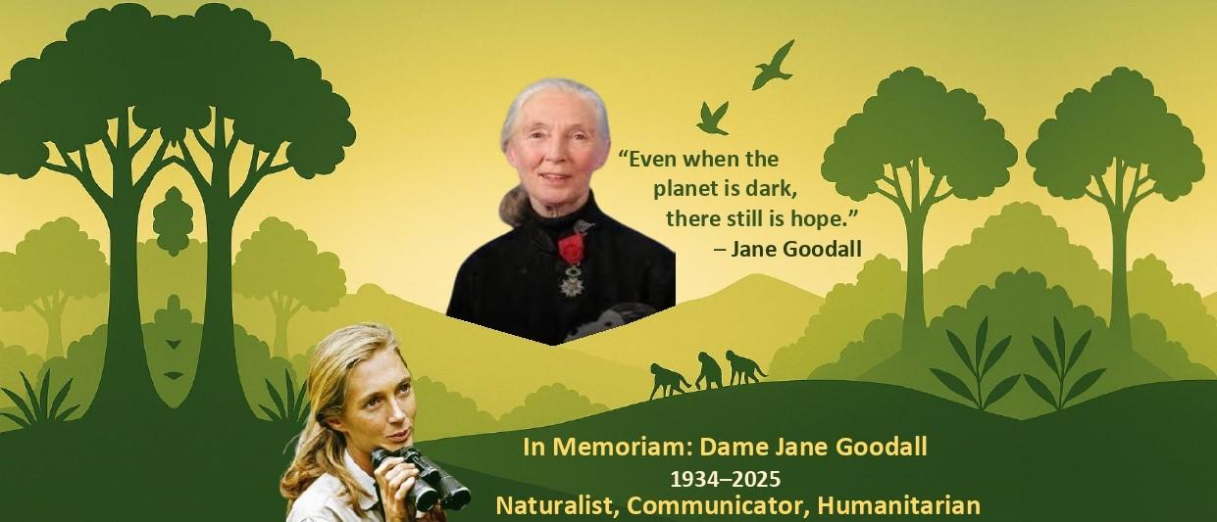

When a schoolgirl at Uplands, Poole, near Bournemouth, Jane Goodall seemed wrapped up in herself, somewhat separate from others, and this may well have become a strength in her long career as a primatologist. Self-possessed, she broke through the prejudices of male scientists to make discoveries. She may also be seen as an ethologist and anthropologist, but above all as a communicator of unifying ideas about human beings and nature. In this she resembles David Bellamy and Sir David Attenborough. Her travelling work for 300 days a year continued until the end of her highly productive life [1].
She is one of a long line of observers in British science, a naturalist, like Gilbert White, Charles Darwin, Charles Raven, David Attenborough, and Chris Packham. Her observations were so good that Louis Leakey persuaded Cambridge to admit her to take a doctorate, although she had no prior degrees, but merely an excellent set of skills as a trained secretary and her knowledge gathered from fieldwork.
Goodall accepted an invitation to visit the farm in Kenya of a friend, and seized the opportunity to introduce herself to Louis Leakey, because she wanted to study animals. Leakey believed that women would be better at studying primates than men, and so encouraged and mentored the fundamental work of Goodall, Fossey and Galdikas.
Goodall's study of chimpanzee behaviour in the Gombe forest, Tanganyika, led her to observe evidence for their being carnivores, and for using tools, notably a grass stem inserted into a termite mound. This produced a reaction which would lead to the capture of the termites as prey. She learned to approach chimpanzees with self-restraint and gentleness and befriended them, giving them names as if they were persons. Some criticized her for this. Others criticized her for recognizing that apes could approach human characteristics but were not equal to human beings [2-5].
Nevertheless, photographs show that Goodall's embrace with chimpanzees was almost sisterly or motherly and was full of love.
Her careful befriending of chimpanzees seems to have resulted from her childhood curiosity about animals and her ability to accept experience. In later years she seems to have had a mystical experience in Notre Dame, Paris [6], but her work did not cause her to take the road of a great palaeontologist and Jesuit, Pierre Teilhard de Chardin; who developed a theology and a philosophy which gave mystical interpretations to science and in particular evolution [7]. Goodall came from a Congregationalist family. She grew up in an all-female household when her father was on active service in World War II. This probably strengthened her self-reliance. When after the war her father and mother divorced, the father’s absence was not noticeable.
Goodall chose well by establishing her work in the United States. This allowed her to inculturate her fair, factual and creative thought in a way which could diffuse good through that complicated society. The Jane Goodall Institute has developed the Roots and Shoots organization, which is a kind of Peace Corps making changes in line with Goodall’s views; and another Institute endeavour is TACARE, targeting villages in Africa, promoting health, education, smart agriculture, and being environment-conscious [8].
Goodall’s views included condemnation of human alpha males engaged in power politics [4]. These views were released by her direction only after her death. As she says,
“Even today, when the planet is dark, there still is hope. Don’t lose hope. If you lose hope, you become apathetic and do nothing…”
“And if you want to save what is still beautiful in this world – if you want to save the planet for the future generations, your grandchildren, their grandchildren – then think about the actions you take each day. Because, multiplied a million, a billion times, even small actions will make for great change.”

References
- https://www.thetimes.com/uk/obituaries/article/dame-jane-goodall-obituary-monkey-expert-n366fl8c0#:~:text=Dame%20Jane%20Goodall%20obituary%3A%20chimp%20expert%20dies%20aged%2091
- https://www.theguardian.com/science/2025/oct/02/dame-jane-goodall-obituary#:~:text=Dame%20Jane%20Goodall%20obituary
- https://www.nytimes.com/2025/10/01/science/jane-goodall-chimpanzees-career.html#:~:text=%E2%80%98There%20Will%20Always%20Only%20Be%20One%20Jane%20Goodall%E2%80%9
- https://www.theguardian.com/science/2025/oct/06/jane-goodall-trump-elon-musk-putin#:~:text=Jane%20Goodall%20said%20she%20would%20launch%20Trump%20and%20Musk%20on%20one%2Dway%20trip%20into%20space
- https://www.abc.net.au/news/2025-10-02/primatologist-jane-goodall-obituary/102197696#:~:text=Jane%20Goodall%2C%20who%20revolutionised%20our%20understanding%20of%20animals%2C%20dies%20at%2091
- https://news.janegoodall.org/2019/04/15/dr-goodalls-thoughts-on-the-fire-of-notre-dame/
- Teilhard de Chardin., P., 1965, The Phenomenon of Man - introduction by Sir Julian Huxley (London & Glasgow: Wm Collins Sons & Co. Ltd.).
- https://salempres.com>Media>SalemPress>samples>greatlives_21st_pgs.pdf

© Michael Brett-Crowther, 2025
drmichaelbrettcrowther@gmail.com

How to cite this article
Brett-Crowther, M., 2025. In Memoriam- Dame Jane Goodall, 1934-2025. Natural Built Social Environment Health 1(5), 239-241. DOI: 10.63095/NBSEH.25.990044

