 | Natural Built Social Environment Health  ISSN 3085-461X  www.nbseh.org | 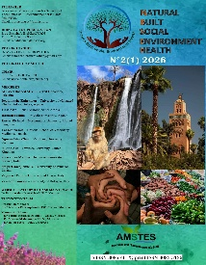

Production and Recycling of Agricultural Mulching Films in Morocco: Challenges, Barriers, and Strategic Pathways

Fatima Azzahra Louanjli ^{1a}, Ghita Radi Benjelloun ^{1b}, Khawla Waddi ^{1c}, FatimaZahra Boutaleb ^{1d}, Rajaa Tesse ^{1e}, Ikrame Charef ^{1f}, Meriem Mahmoudi ^{1g}, Bouchaib Bahlaouan ^{2h}, & Nadia Boutaleb ^{1i}*

¹ Hassan II University of Casablanca , Laboratory of Biotechnology, Agri-Food, Materials and Environment, Team: Biotechnologies, Resource Valorization, Quality, Health and Ecotoxicology, Faculty of Science and Technology Mohammedia, BP 146, Mohammedia 20650, Morocco
² Higher Institutes of the Nursing Professions and Techniques of Health (ISPITS) , Laboratory of Care, Health and Sustainable Development 2S2D, Casablanca 22500, Morocco

ª ORCID: 0000-0002-3482-3828; Email: f.louanjli@gmail.com
^{b} ORCID: 0000-0002-9884-8119; Email : ghita.radibenjelloun@etu.fstm.ac.ma
^{c} ORCID: 0000-0001-9820-2265; Email: khawla.waddi@etu.fstm.ac.ma
^{d} ORCID: 0000-0002-1996-8607; Email: fatima.boutaleb2-etu@etu.univh2c.ma
^{e} ORCID: 0009-0001-1921-3159; Email: rajaa.tesse-etu@etu.univh2c.ma
^{f} ORCID: 0009-0004-4591-8269; Email: ikramegp2017@gmail.com
^{g} ORCID: 0009-0002-2682-2478; Email: meriem.mahmoudi2-etu@etu.univh2c.ma
^{h} ORCID: 0000-0002-0976-1274; Email: b.bahlaouan@ispitscasa.ac.ma
^{i} ORCID: 0000-0003-1628-4311; Email: nadia.boutaleb@fstm.ac.ma

*Corresponding author: Nadia Boutaleb; Email: nadia.boutaleb@fstm.ac.ma

Graphical Abstract

Agricultural mulching films in Morocco raise yields, reduce pesticide use, and improve water efficiency. Yet poor recyclability causes soil and water pollution and microplastic spread. A survey of ten companies shows high reliance on virgin polymers, short lifespan, and recycling rates below 30%. Strategic pathways include a plastic tax, subsidies, robust monitoring, and integration with green transition policies to build a circular economy.
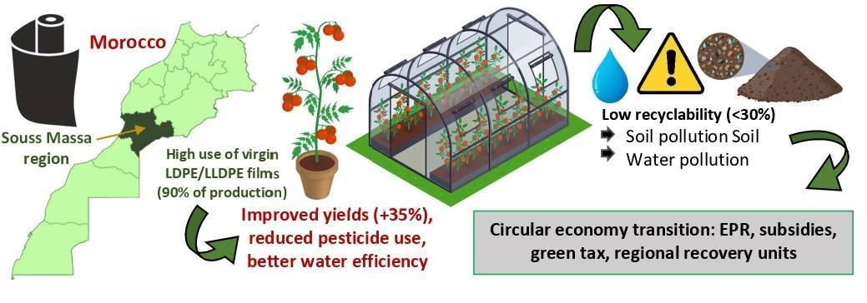
DOI : 10.63095/NBSEH.26.787520  Received: 23 November 2025  Revised: 21 January 2026  Accepted: 03 February 2026  Published online: 07 April 2026  Citation: Louanjli, F. A., Radi Benjelloun, G., Waddi, K., Boutaleb, F. Z., Tesse, R., Charef, I., Mahmoudi, M., Bahlaouan, B., & Boutaleb, N., 2026, Production and Recycling of Agricultural Mulching Films in Morocco: Challenges, Barriers, and Strategic Pathways. Natural Built Social Environment Health 2(2), 78-103. http://www.doi.org/10.63095/NBSEH.26.787520 | Abstract: Agricultural mulching films, mainly made from low-density polyethylene (LDPE), play a central role in Morocco's agricultural development, particularly in high value-added regions such as Souss-Massa and Gharb. They reduce the use of plant protection products, while increasing yields and saving water resources. The lack of recovery and recycling of these films has a major polluting effect on the environment. This study analyses the Moroccan mulch film sector, based on a survey of ten leading companies in the plasticulture sector, using tools such as the Ishikawa diagram, SWOT analysis, and risk analysis. The results show a high dependence on virgin polymers, with a recycling rate rarely exceeding 30%. The World Bank has set out a roadmap for 2028. Such measures could transform Moroccan plasticulture from an ecological burden to a real benefit.  Keywords: Agricultural mulching films, Recycling barriers, Circular economy.

Introduction
For centuries, market gardening has provided food and improved living conditions for populations. For example, the Pharaohs grew a variety of vegetables, including onions, beans, cucumbers, lettuce, and radishes. [1]. The Romans also practised market gardening based on both self-sufficiency and local market sales. They cultivated vegetables such as celery, fennel, and coriander, as well as fruits such as cherries and peaches [2]. During the Middle Ages, monastery gardens contained a variety of vegetables [3]. According to the Bibliothèque nationale de France (2023), the term “maraîchage” (market gardening) appeared in the 18th century in connection with the vegetable gardens developed in the Parisian marshes, which covered the needs for vegetables and fruit [4].
The Industrial Revolution’s use of the steam engine, specifically in England between the 18th and 19th centuries, transformed the agricultural sector because the steam engine and railway transport allowed movement of produce to market more rapidly and at long distance [5,6]. Subsequently, the exploitation of resources such as natural gas, oil, and coal became established as non-renewable energy sources, leading to the appearance of the first agricultural tractor with an internal combustion engine. This expansion marked the modernization of agriculture, particularly in 1908, with the advent of nitrogen fertilizers thanks to the Haber-Bosch process. This progress improved soil fertility and significantly increased agricultural yields [7]. After World War I, in order to meet growing global demand and protect crops, the development of synthetic insecticides became essential [8].
In Morocco, agriculture is a pillar of the national economy. It has a major impact on employment, particularly in rural areas, ensuring food security and contributing to export development. This sector accounts for about 15% of the country’s Gross Domestic Product (GDP) (Ministry of Agriculture, Rural Development, and Water and Forests) [9], making it a strategic priority for Morocco.
The Souss-Massa and Gharb plains are pioneers of market gardening in Morocco, serving as key production and export hubs for vegetables, and ranking as the third largest tomato exporter. Together, they account for nearly 58% of total fresh vegetable production and exports, with an estimated volume exceeding 560,000 tonnes and a total value of about 7.5 billion dirhams [10].
National strategies maintain the process of agricultural development. The Green Morocco Plan (PMV) [11], implemented from 2008 to 2020, was followed by Génération Green 2020–2030 [12], which aims to consolidate agricultural achievements, promote technological modernization, and strengthen farmers’ integration into efficient agricultural organizations [10,13]. Following the positive outcomes of these programmes, a long-term agricultural strategy, Vision Agricole 2050, was launched to enhance the adaptability of Moroccan food systems to climate change [14,15].
In a context marked by climatic and pollution-related challenges, sustainable, efficient production with higher yields has become essential. This all depends on irrigation. National water consumption reaches about 16.28 billion m³, of which 89.26% is used for irrigation and only 10.74% for domestic, industrial, and tourism purposes [16]. Morocco’s water needs are becoming very serious. This persistent drought 2022-2023 has significant impacts on available water levels and, consequently, on agricultural production. According to the High Commission for Planning (HCP), adverse climatic conditions marked by rainfall deficits and thermal anomalies have reduced yields during the 2022–2023 agricultural season [16].
Beyond this water stress, pollution of groundwater and surface water has become an alarming environmental concern for Moroccan agriculture. The excessive use of pesticides and fertilizers causes severe consequences by contaminating both water and soil [17,18].
It is essential to promote alternative and sustainable solutions. Since the 1970s, plasticulture has been established in Morocco. It encompasses a wide range of agricultural techniques, including mulching and drip irrigation; particularly in the Souss-Massa region [19].
This system, laid flat on the soil, brings significant benefits to agriculture. For example, for saffron cultivation (Crocus sativus L.), a study demonstrated that the use of polyethylene mulch film in the Oriental region effectively reduced weeds such as Cynodon dactylon and Aster squamatus, resulting in a 9% yield increase compared to the control. It also improved the vegetative development of the plant [20].
Findings from another study conducted in Taounate showed that soil covered with vegetation or mulch retained moisture more effectively and reduced water loss from evaporation compared to bare soil [21]. Likewise, another study confirmed that in production areas such as Loukkos and Souss-Massa, the efficiency of plastic tunnel films resulted in a 35% yield increase compared to uncovered strawberry plants, with a visible improvement in fruit quality. Moreover, this 150-micron film enhanced light diffusion and plant growth [22].
In the Souss-Massa region, the use of plastic mulch films is often associated with fumigants to ensure optimal use of phytosanitary products such as methyl bromide and metam sodium. These are applied to disinfect and improve soil quality. Farmers generally adopt an integrated pest management approach combining several techniques: rational irrigation and fertilization, the use of greenhouses and insect-proof nets, and the installation of plastic mulch. This method ensures efficient and sustainable control of pests and diseases [23,24].
Mulch films play a crucial role in reducing the use of inputs by limiting chemical pollution of soil and water. They help to maintain soil moisture, in an agricultural approach aimed at protecting terrestrial and aquatic biodiversity.
Fertilizer applications are designed to meet the growing food demand and to ensure food security [25,26]. To improve yields, the use of fertilizers has become widespread. Non-compliance with recommended dosages, combined with the effects of rainfall or irrigation, leads to infiltration into groundwater, threatening the quality of water resources [27,28]. Soil pollution has thus become a major problem, with the risk of long-term degradation of agricultural ecosystems.
According to the European Environment Agency (EEA), this pollution largely results from the direct introduction or burial of chemical substances such as phytosanitary products, fertilizers, and agricultural plastics. The intensification of agricultural practices and extensive use of pesticides also contribute to air pollution. During their application or degradation, these compounds can volatilize, disperse into the atmosphere, and alter air quality, with significant repercussions for human health [29].
The long-term use of agricultural plastic films leads to major environmental pollution consequences. Their limited recyclability, burial in soil, and dispersal into nature seriously threaten the quality of surface water and groundwater. The problem is intensified by the lack of structured collection and recovery systems, the predominance of informal networks, and the low recycling rate (generally below 30%) [30].
Yet, in contrast, there are pioneering regional initiatives, such as that of the AgroTech Souss- Massa Association, which has established recovery units capable of processing up to 55,000 tonnes of agricultural plastic waste per year, representing more than 50% of the national total. There needs to be further effort at the national level, where economic, logistical, and regulatory barriers persist.
The present study aims to provide a systemic approach to the agricultural mulch film sector in Morocco. Its objectives are to assess the evolution of LDPE production and use in agriculture, identify current practices and barriers related to recycling and the management of agricultural plastic waste, examine internal and external strategic factors structuring this sector through an Ishikawa analysis, analyse its internal and external context using a SWOT framework of strengths, weaknesses, opportunities, and threats, and finally, to carry out a risk analysis to propose actions for sustainability, which will improve competitiveness, and support alignment with international standards.

Materials and Methods

Type and study design
The main objective of the survey was to collect quantitative and qualitative data on domestic production of low-density polyethylene mulch film; to identify the most commonly used materials, according to their type, origin, and composition; to assess current recycling practices; to identify the constraints encountered; and, finally, to understand the environmental awareness of the manufacturers, particularly through the acquisition of labels or certifications. The study integrates technical, economic, and environmental dimensions.

Population and sample
As part of a field assessment, telephone discussions and face-to-face interviews were conducted to identify a well-defined panel of Moroccan companies working in the production, distribution and, where applicable, management of agricultural plastic film recycling. The companies were selected so as to cover the most important agricultural plastics industries at the regional level: Casablanca, Agadir, Fez, and Marrakesh. The selection criteria were as follows:
• Major companies in the plastics industry in Morocco;
• Their production of agricultural LDPE mulch films;
• Accessibility and openness.
The survey targeted Moroccan companies specializing in the manufacture and marketing of agricultural films. Ten companies considered to be major players in the market were selected on the basis of their representativeness in terms of market share and product diversity. Their participation was voluntary after prior information on the objectives of the research

Data collection instrument
Data were collected through a structured questionnaire designed using the Google Forms platform. The questionnaire included closed, semi-open, and open questions, divided into six main sections:
- Company profile (size, location, market share);
- Types of materials and mulch films produced.
- Agricultural uses (targeted crops, application regions, film lifespan);
- Production and distribution volumes ;
- Collection, recycling, and recovery practices;
- Perceptions of barriers, constraints, and opportunities within the sector.
Data collection and analysis
The questionnaire was distributed electronically between January and March 2025. Companies were given four weeks to respond. A reminder was sent midway through the period to improve the response rate. Data were automatically collected in digital format.
Responses were processed and coded in Microsoft Excel for both quantitative and qualitative variables. Descriptive statistics (frequencies, percentages, and means) were used to summarize the results. Data were then presented as pie charts, histograms, and maps to illustrate the main trends.

Reliability and limitations
The participation of ten companies is a limitation in terms of statistical representativeness. Their significant weight in the national market nonetheless provides analytical value to the sample. The absence of data from informal producers and small distributors narrows the scope of the results, but the chosen approach allows the identification of strong trends in the sector’s dominant practices.

Results and Discussion
Figures 1 and 2 show, respectively, the distribution of materials used by Moroccan companies for the production of agricultural mulch films and the types of films produced. These data provide a clearer understanding of the technological choices favoured by the sector and the dominant production trends.
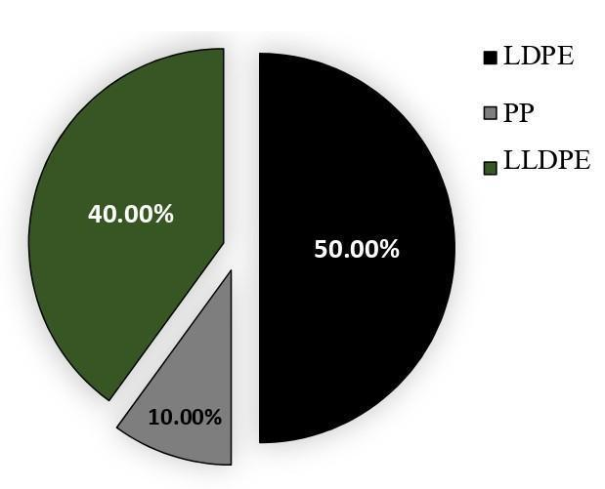
Figure 1. Materials used by the companies interviewed
Figure 1 shows that low-density polyethylene (LDPE) dominates the chart with a 50% share, followed by linear low-density polyethylene (LLDPE) with 40%. This reflects the importance of these two materials, which are considered benchmarks for agricultural films, mainly because of their favourable cost–performance ratio for users. Research [31, 32] indicates that LLDPE presents certain processing limitations. It is more difficult to extrude owing to its low polydispersity (narrow molecular-weight distribution), which can cause surface irregularities such as cracks, misalignments, or deformations.
A review of the literature, summarized in Gregory [32] Table 1 below, supports these graphical results: both LDPE and LLDPE are widely used in agricultural films. Gregory [32] explains that incorporating 25% LLDPE into an LDPE matrix significantly improves the film’s mechanical strength and toughness and facilitates extrusion. This complementarity combines lower cost with greater resistance and stability in agricultural films. Finally, polypropylene (PP) represents only 10% of the chart, which can be attributed to its adaptation to specific uses.

Table 1. Polymers used for agricultural films
PE Type | M.I (dg/min) | Density (g/cm³) | Comment
LDPE | 0.2 | 0.919 | Mulch, silage, tunnels
LDPE | 0.3 | 0.922 | Tunnels, silage
LDPE | 0.4 | 0.923 | Greenhouse
LDPE | 0.4 | 0.950 | Greenhouse
LDPE | 0.4 | 0.924 | 2 & 4 season film
LDPE | 0.5 | 0.918 | Greenhouse
LDPE | 0.6 | 0.920 | 3 seasons
LDPE | 0.6 | 0.926 | Tunnels
LDPE | 2.0 | 0.918 | GP film (tunnels/mulch/cover)
LDPE | 2.0 | 0.917 | GP film (mulch/cover)
LLDPE | 0.20 | 0.918 | Silage bags and blending
LLDPE | 0.30 | 0.919 | Silage bags and blending
LLDPE | 0.40 | 0.922 | Blending/tunnels
LLDPE | 0.90 | 0.917 | Tunnels, mulch
LLDPE | 1.0 | 0.923 | Silage bags and blending
LLDPE | 2.0 | 0.926 | Silage bags and blending
Source : Gregory [32]

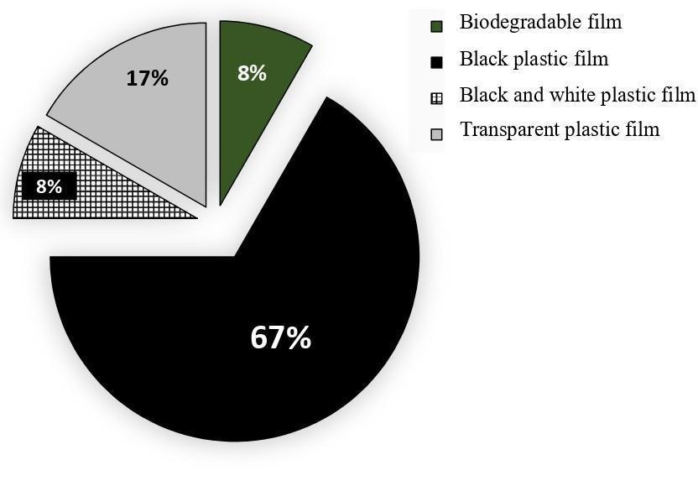
Figure 2. Type of film produced by the companies questioned

Figure 2 illustrates the distribution of plastic film types used by companies. Black plastic film dominates with 67%, reflecting strong market demand. This film is stabilized with carbon black, which makes it resistant to photodegradation. It is widely used for its low cost [33], its superior characteristics compared to intermediate opaque films, its significant ability to reduce soil evapotranspiration, and its efficiency in limiting weed growth [34,35].
Scientific studies confirm that black plastic film acts as an almost total absorber of visible and infrared solar radiation. This high absorption of solar energy can cause heat accumulation [36]. In hot or tropical climates, this may lead to scorching of leaves or fruits, damaging crop quality [37, 38].
Transparent plastic films account for 17% of the chart. Their use by farmers is linked to their ability to promote early yields through rapid soil warming [39]. This type of film has a major limitation related to its weak herbistatic effect. Being translucent, it stimulates weed germination, making it less effective for weed control [40].
Bicolour and transparent plastic films represent only 7% of the chart, showing limited use compared to other types. The adoption of biodegradable films remains financially challenging, as demonstrated by Velandia et al. [41] and Hao et al. [42]. The significant extra cost of biodegradable mulch films (BDM) compared to conventional polyethylene (PE) films, in addition to transport costs, forms a major obstacle to their adoption by farmers. Public subsidies or economic incentives are therefore needed to encourage their use.
Although bicolour films offer considerable advantages by combining the benefits of two types of films (heat control and weed suppression) [43], their practicality remains limited. They require more technical installation and are restricted to certain specific crops, which explains their modest position in the market [44,45].

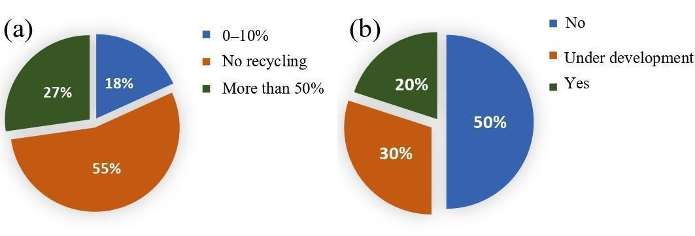
Figure 1. (a) Recycling rate of surveyed companies; (b) Proportion of companies with a collection program

Agriculture contributes 13% of Morocco’s GDP. According to the results of the 2024 General Population and Housing Census, the Kingdom’s population stands at 36,828,330 inhabitants [46]. The country has over 9 million ha of agricultural land and 30.4 million ha of pastoral land, continuously used for livestock grazing, which underlines the strategic importance of the agricultural sector.
Nevertheless, this sector exerts significant pressure on the ecosystem through soil degradation (erosion, clearing, salinization, desertification, overexploitation) and contributes considerably to national greenhouse gas emissions (24.6%). In addressing these challenges, Morocco has taken a proactive approach by implementing several national structuring programmes. The Green Morocco Plan focused on a circular approach aimed at agricultural waste recovery. More recently, the Generation Green 2020–2030 strategy has promoted the sustainable use of these resources. It encourages the growth of an innovative ecosystem mainly driven by research and development and by collaboration among all stakeholders, forming a strategic lever for sustainable agriculture by 2030 [47].
The study explored the practices of mulch film production companies regarding recycling, as shown in Figures 30a and 30b. It was observed that 50% of companies have no collection programme, which aligns with the proportion of 55% that do not carry out any recycling. Only 20% of companies reported having established a collection programme, corresponding to the 27% engaged in recycling more than half of their mulch films. Finally, it is notable that 30% of companies are in the process of implementing their recycling systems. This willingness remains constrained by several causes, which partly explains the 18% of companies limiting recycling to a low level (0–10%). These results will be further analysed using an Ishikawa diagram to identify the underlying causes.
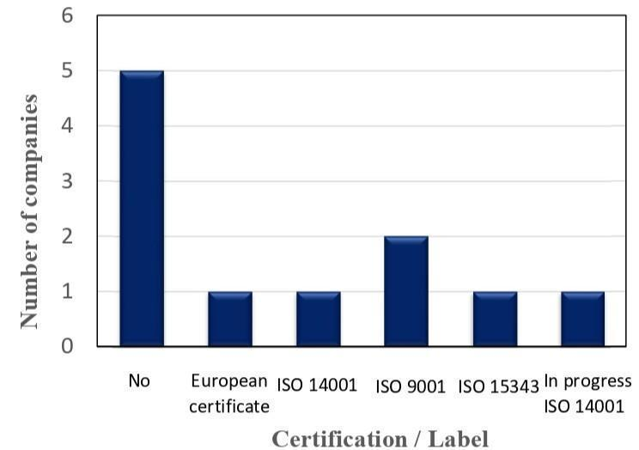
Figure 3. Distribution of companies according to possession of environmental certifications or labels

According to Figure 3, most companies do not follow an organized approach to control the environmental impacts linked to mulch film production. This can be partly explained by economic factors: a new mulch film costs between 20 and 25.5 MAD/kg, whereas its recovery value is only 1.80 to 2.30 MAD/kg, representing about 9% of its initial value. This profit remains negligible compared with the expenses generated by the process. The Extended Producer Responsibility (EPR) principle, derived from the “polluter pays” concept, first appeared in France for household waste management. Today, this principle is being developed for the bottling sector in Morocco. According to Benqlilou et al. [48], integrating EPR into household packaging waste management places greater responsibility on producers than on municipalities. Implementing this system could significantly increase the quantity of processed materials (plastic, glass, cardboard, etc.).
Thus, the mulch film sector remains in a rudimentary state and must align with this system to ensure its recovery. Lamrani-Jouti [49] and Yemli & Bengueddour [50] report that Moroccan companies, particularly SMEs, view the integration of an environmental management system mainly as an additional cost. Yemli & Bengueddour [50], sampling 68 Moroccan companies, confirm this perception.
In contrast, the chart shows that a minority of companies have adopted an organizational framework (certifications, labels, or continuing programmes) enabling them to reduce their impacts, engage in continuous improvement, and contribute to ecosystem protection while meeting market expectations and regulatory obligations. This trend is confirmed by Hasnaa [51], who shows that some certified or labelled Moroccan businesses follow an eco-responsible approach. This approach strengthens brand reputation, opens new markets, and improves economic efficiency. Ultimately, it supports the Porter and Van der Linde [52] hypothesis, which states that well-designed environmental regulation stimulates business innovation, balances costs, and enhances competitiveness.

Analysis of the causes of non-recycling
Based on the causes identified by the companies, both through questionnaire responses and producer interviews, it appears that the low recycling rate of agricultural mulch films results from several structural factors. These factors can be grouped according to the classical categories of the Ishikawa diagram, illustrated in Figure 4 below: labour, methods, materials, machines, and management/regulation.
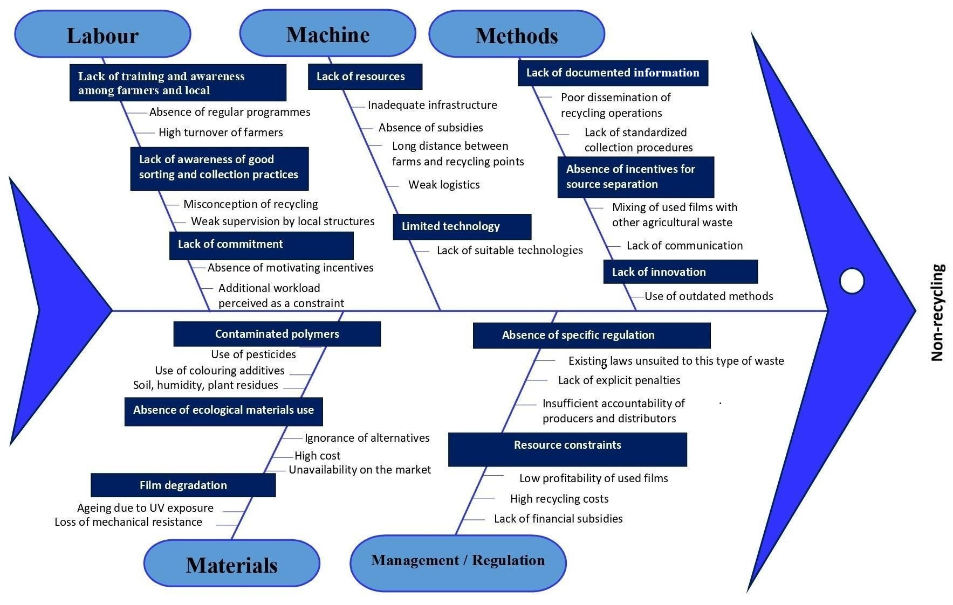
Figure 4 : ISHIKAWA diagram
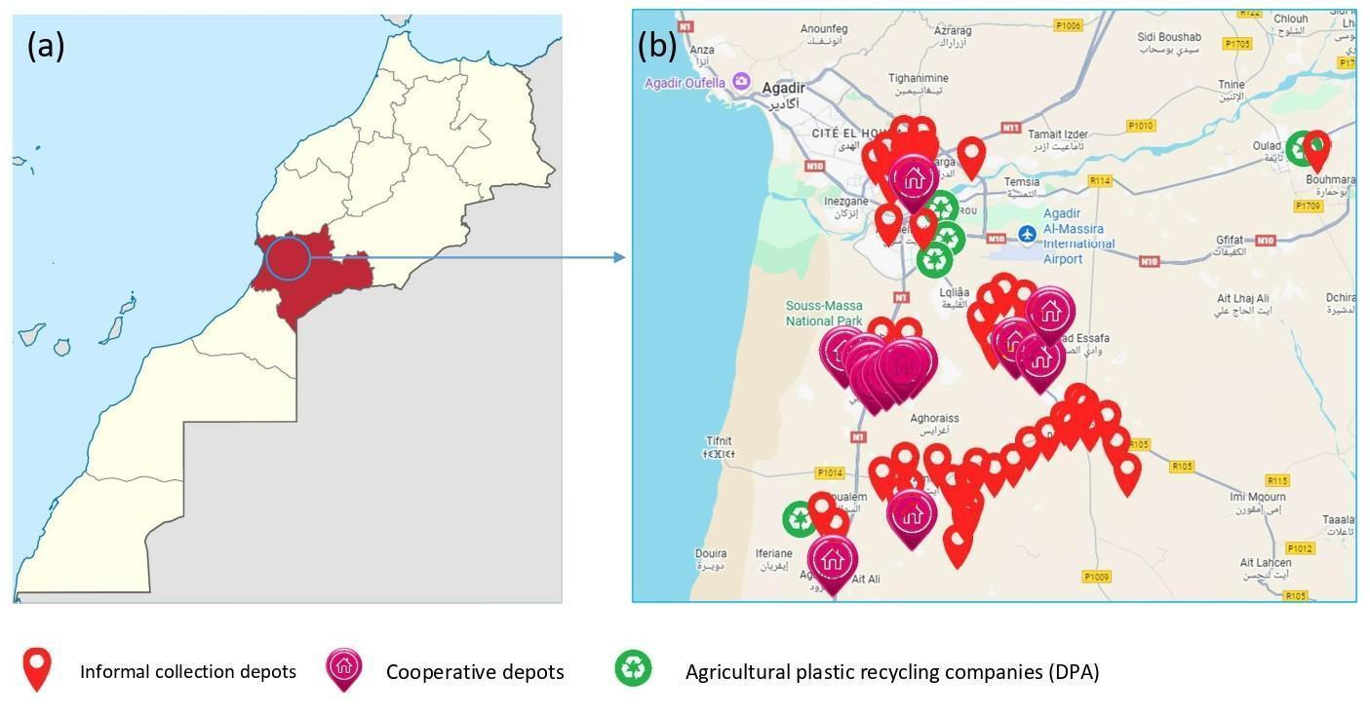
Figure 5. (a) Location of the Souss-Massa region in Morocco; (b) Geographic distribution of agricultural plastic waste (APW) collection and recycling operators identified during the field survey and on-site investigations conducted in the Souss-Massa region
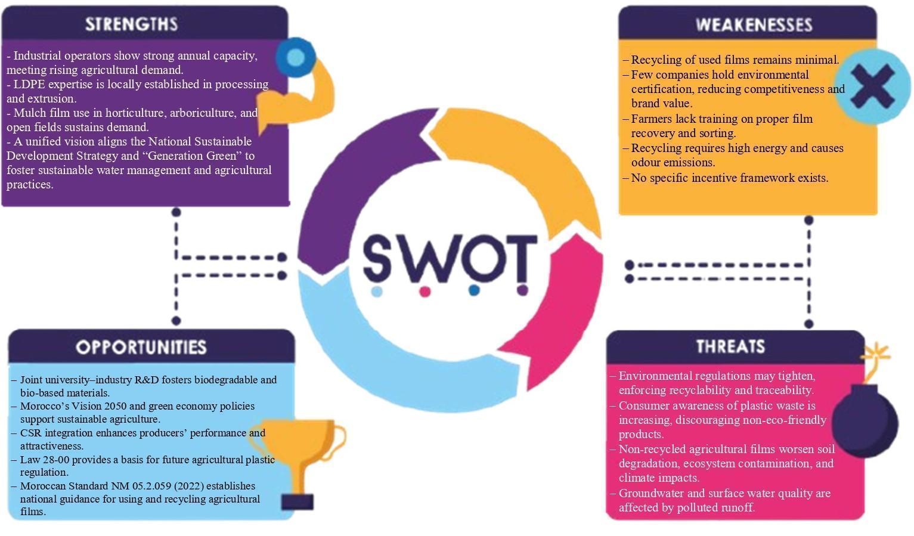
Figure 6: SWOT analysis
The Ishikawa diagram, illustrated in Figure 4 helped identify the various causes that slow down or hinder the recycling process for agricultural plastic films. With regard to the “labour” category of causes, local authorities, in other words regional authorities, play an important role in Morocco, with the aim of satisfying common needs and interests, and have responsibility for household and similar waste disposal. Through awareness-raising, communication, and incentive measures, they are able to engage with citizens to reduce waste and encourage them to adopt good sustainable practices [53]. For example, Law No. 77-15, known as “Zero Mika,” in force since July 2016, banned the production, import, and sale of plastic bags [54]. This initiative demonstrated the strong mobilization of local authorities, combined with other efforts by several stakeholders (non-governmental organizations, associations, etc.), which constituted a major lever for supporting changes in practices. A similar approach could be replicated in the agricultural sector, especially in regions which manufacture and use various agricultural plastic films. The deployment of various measures by local authorities could improve the agricultural plastic waste recovery chain. These actions could include raising awareness, training, and informing producers and users (farmers) and establishing good waste collection and sorting practices.
In terms of methodology, the lack of documented information refers to the lack of traceability of all essential data, in various forms, whether procedures, work instructions, or control sheets, etc.
In recent years, Morocco has undertaken various actions to improve the management of agricultural plastic waste (APW), mainly in the Souss-Massa region, the leading generator of this type of waste. According to Saber [55], the recycling rate has increased from 18% in 2020 to 45% in 2023. In this regard, a partnership agreement has been signed between the Ministry of Energy Transition and AgroTech Souss-Massa. More efforts are desirable in other regions that produce agricultural waste, such as Loukkos associated with the province (Larache), Gharb (Rabat-Salé-Kénitra), and Doukkala (Casablanca-Settat) [56, 57]. In comparison, data from the 2024 activity report of the CPA (Plasticulture and Agro-Environment Committee) (collection up 20% since 2020, smoothed rate at 71%, recycling at 62%) [58] show significant discrepancies. The formalization of procedures, work instructions, and data traceability remains essential for monitoring performance indicators and achieving defined objectives. For example, where mulch film deteriorates by exposure to UV, excessive exposure causes its mechanical properties to deteriorate, making it difficult to recycle after ageing [59].
Despite the obstacles identified at the national level, regional initiatives can - if continued - strengthen the recycling sector. This is the case with the AgroTech Souss-Massa Association, established in 2006 at the initiative of the Regional Council. Since 2013, AgroTech SM, in cooperation with the Regional Council and the Crédit Agricole du Maroc Foundation for Sustainable Development, has been engaged in structuring the agricultural plastic waste (APW) recycling sector. Several actions have been implemented, including the grouping of nine recycling companies, the creation of eleven cooperatives from the informal sector, and the establishment of a regional action plan to improve agricultural waste management.
Recently, AgroTech SM introduced an agricultural plastic recovery unit in Drarga. This facility aims to process 55,000 tonnes of agricultural plastic waste per year, representing more than 50% of the national total. Thus, the deployment of national strategies should extend to all relevant regions, following the example of the initiative launched in the Souss-Massa region [30-47]. Despite these structuring efforts, the management of agricultural plastics remains dominated by the informal sector, as clearly illustrated by the mapping presented in Figure 5. This mapping is based on the field survey and on-site investigations conducted as part of the present study.
Figure 5 focuses on the Souss-Massa region and shows the geographic distribution of agricultural plastic waste (APW) collection and recycling actors identified during the fieldwork. It highlights the predominance of informal collection depots (orange icons), mainly located near intensive agricultural areas, compared to cooperative depots (purple icons) and formal APW recycling companies (green icons).

Analysis of internal and external challenges at the national level
To complement the cause–effect analysis, a SWOT matrix was established to assess the current strategic situation of the LDPE mulch film sector in Morocco. This method highlights internal factors (strengths and weaknesses) as well as external factors (opportunities and threats) in order to identify relevant action levers. It thus provides better visibility of the actions to be undertaken to respond effectively to national and international market requirements while ensuring ecosystem protection.
In continuity with the Ishikawa diagram, which revealed all the risks and threats, the SWOT analysis provided an overall view of the challenges facing the mulch film sector in relation to the country’s context and its development in this field. It is important to extend the analysis towards a qualitative risk assessment to categorize the identified risks accurately and propose appropriate control measures.

Table 2. Strategic, Regulatory, Economic, Environmental, and Social Risks Affecting the Agricultural Plastic Film Recycling Sector
Identified Risk | Causes | Consequences | Proposed Actions
Regulatory Risk | Lack of specific regulation adapted to agricultural plastics and weakness in managerial aspects | Persistence of the informal sector, lack of traceability in waste flows, difficulty in structuring the value chain | Establishment of a clear regulatory framework (agricultural EPR), integration of producers and distributors in waste management, implementation of a practical and efficient traceability system
Economic Risk | Low profitability (resale price = 9% of initial price), high collection and recycling costs | Insufficient economic incentives for companies and farmers in recycling, stagnation of the value chain | Financial incentives (subsidies, green taxation), support for cooperatives, promotion of local valorization
Environmental Risk | Abandonment or burning of used films, use of contaminated polymers | Soil degradation, water contamination, greenhouse gas emissions | Deployment of regional recycling units, promotion of biodegradable materials
Social Risk | Lack of awareness and training among farmers and local authorities | Persistence of the informal sector | Inform, train, and financially motivate farmers to adopt sustainable practices. By understanding environmental impacts, they protect their land and ensure the sustainability of their agricultural activities.
Strategic Risk | Low level of integration of eco-innovative approaches, limiting ambitions for certification and environmental labelling | Loss of export market share, reduced stakeholder confidence, deterioration of brand image | Support for certification processes, encouragement of eco-innovation and the circular economy, leveraging university-industry partnerships as a driver for development

The risk analysis task brought together all the causes, threats, and risks identified previously. It clearly shows that the mulch film recycling sector faces regulatory, economic, environmental, social, and strategic obstacles. Accordingly, it appears essential to establish recycling units in all the regions concerned, starting with Souss-Massa, following established procedures for this sector.
The proposed actions are in line with the roadmap established by the World Bank, in collaboration with the Ministry of Energy Transition and Sustainable Development of the Kingdom of Morocco [60, 61], to reduce WEEE. This roadmap provides for incentives to be put in place until 2028. By focusing on the development of sustainable solutions, it accords with the promotion of agricultural mulch film and the development of biodegradable materials. There should be taxes on conventional plastics or, failing that, the strengthening of subsidies and the improvement of green taxation. New standards should specify the acceptable features of biodegradable films made from thermoplastic materials designed for mulching applications.
According to the Ministry of Energy Transition and Sustainable Development [62], Morocco's interest in Extended Producer Responsibility (EPR) shows its commitment to sustainable development and the green economy. It is just a few steps away from its strategy to structure the plastics recycling sector. This first initiative focused on PET (polyethylene terephthalate) water bottles, which constitute a pilot case on a national scale.
Conclusion
The field study conducted among Moroccan manufacturers of mulch films revealed several major barriers to the recycling of agricultural LDPE. These include insufficient infrastructure, limited user awareness, lack of knowledge or enforcement of existing regulations, and the absence of incentives promoting the circular economy.
The SWOT analysis and Ishikawa diagram provided a systemic understanding of these obstacles, highlighting the urgent need for a national strategy structured around recyclability, ecological certification, and farmer training. Moreover, integrating risk assessment remains essential to anticipate and manage future impacts. A precise action plan is indispensable.

Acknowledgments: The authors would like to thank the CNRST for all their financial and technical support.
Data Availability: The data that support the findings of this study are available from the corresponding author upon reasonable request.
Code availability: Not applicable
Conflict of interest: All authors declare no conflicts of interest

References
- Warid, W. A., 1994, Vegetable species known to the ancient Egyptians. Horticulture in Human life, Culture and Environment 391, 283-290. https://doi.org/10.17660/ActaHortic.1995.391.29
- Marzano, A., 2022, Plants, Politics and Empire in Ancient Rome (Cambridge: Cambridge University Press). Theoretical Roman Archaeology Journal 7(1): 1–4. https://doi.org/10.16995/traj.17906.
- Åsen, P. A., 2021, Medieval monastery gardens in Iceland and Norway. Religions 12(5), 317. https://doi.org/10.3390/rel12050317
- Bibliothèque nationale de France, 2023, Le maraîchage : une pratique aux portes des villes. Bibliographie sélective. Paris : Bibliothèque nationale de France. https://www.bnf.fr/sites/default/files/2023-05/Bibliographie%20_%20Mara%C3%AEchage%20_%20Avril%202023.pdf
- Overton, M., 1996, The Agricultural Revolution Reconsidered. In: Agricultural Revolution in England: The Transformation of the Agrarian Economy 1500–1850. (Cambridge: Cambridge University Press), pp. 193-207. https://doi.org/10.1017/CBO9780511607967
- Knittel, F., 2024, Chapitre 4. Mécanisation, chimie agricole et enjeux environnementaux d’une agriculture productiviste (1815–1914). In: F. Knittel (Ed.), Vivre à la campagne en France, de 1815 aux années 1970 Capes Agrégation Histoire-Géographie, collection Horizon, (Paris: Armand Colin), pp. 90–19. https://doi.org/10.3917/arco.knitt.2024.01.0090
- Danso, S. K. A., & Eskew, D. L., 1984, Enhancing biological nitrogen fixation. IAEA Bulletin 26(2), 29-34. Available at: https://www.iaea.org/sites/default/files/26206882933.pdf
- Soula, J. J., 2012, Gouvernance mondiale de l’alimentation et de l’agriculture : état des lieux et perspectives. Bulletin de l’Académie Vétérinaire de France 165(4), 365–368. https://doi.org/10.4267/2042/48820
- U.S. Department of Commerce, 2025, Agricultural sector. In: Country commercial guide: Morocco. U.S. International Trade Administration. Available at : https://www.trade.gov/country-commercial-guides/morocco-agricultural-sector
- Ait Hou, M., 2013, Export supply chain organization and food safety and quality standards: A case study of the Moroccan fruit and vegetable sector. Doctoral dissertation, Alma Mater Studiorum – Università di Bologna Bologna, Italy. Available at: http://amsdottorato.unibo.it/5918/
- Inter-réseaux Développement rural, 2016, The Green Morocco Plan: The major principles and advances of Morocco’s agricultural strategy (Food Sovereignty Brief No. 20). SOS Faim. Available at : https://www.inter-reseaux.org/wp-content/uploads/bds_no20_plan_maroc_vert_en.pdf
- World Bank, 2020, Morocco Green Generation Program-for-Results (P170419) (Report No. PAD3800). International Bank for Reconstruction and Development. Available at : https://documents1.worldbank.org/curated/en/245801608346893390/pdf/Morocco-Green-Generation-Program-for-Results-Project.pdf
- Belahsen, S., Khellaf, A., & Belahsen, M., 2016, Évaluation de la stratégie agricole du Maroc (Plan Maroc Vert) : Une analyse en équilibre général dynamique. Dossiers de Recherches en Économie et Gestion 5(1), 13–46. https://doi.org/10.34874/IMIST.PRSM/doreg-v5i1.15224
- Le Matin, 2025, Le Maroc prépare sa « Vision agricole 2050 ». Le Matin. Available at : https://lematin.ma/economie/vision-agricole-2050-la-nouvelle-strategie-du-royaume-pour-lagriculture/303913
- AgriMaroc, 2025, Une vision agricole 2050 pour anticiper les défis du siècle. AgriMaroc. Available online at :https://www.agrimaroc.ma/une-vision-agricole-2050-pour-anticiper-les-defis-du-siecle/
- Haut-Commissariat au Plan (Maroc), 2024, Budget économique prévisionnel 2024 : La situation économique en 2023 et ses perspectives en 2024, Haut-Commissariat au Plan. Available at :https://www.hcp.ma/Budget-economique-previsionnel-2024_a3807.html
- Farahy, O., Laghfiri, M., Bourioug, M., & Aleya, L., 2021, Overview of pesticide use in Moroccan apple orchards and its effects on the environment. Current Opinion in Environmental Science & Health 19, 100223. https://doi.org/10.1016/j.coesh.2020.10.011
- De Rosa, E., Cerino, P., Triassi, M., Di Duca, F., Porreca, A., Russo, I., Scippa, S., Venuta, A., Coppola, A., Pizzolante, A., Nicodemo, F., Trama, U., Policino, F., & Montuori, P., 2025, Contamination assessment and risk evaluation of organophosphorus pesticides in groundwater: A study on contamination patterns and implications. Journal of Hazardous Materials Advances 18, 100701. https://doi.org/10.1016/j.hazadv.2025.100701
- Fondation Crédit Agricole du Maroc pour le Développement Durable & Association AgroTech Souss-Massa, 2021, Projet de collecte et de valorisation durable des déchets plastiques agricoles dans la région Souss-Massa (Maroc : Groupe Crédit Agricole du Maroc – Fondation pour le Développement Durable). Available at : https://www.fellah-trade.com/ressources/pdf/guide-plastiques-agricoles-fr.pdf
- Mzabri, I., Rimani, M., Charif, K., Kouddane, N., & Berrichi, A., 2021, Study of the effect of mulching materials on weed control in saffron cultivation in Eastern Morocco. The Scientific World Journal 2021, 9727004. https://doi.org/10.1155/2021/9727004
- Nsabiyumva, J. M. V., Apollonio, C., Castelli, G., Petroselli, A., Sabir, M., & Preti, F., 2023, Agricultural practices for hillslope erosion mitigation: A case study in Morocco. Water 15(11), 2120. https://doi.org/10.3390/w15112120
- Imane, M., Ahlam, H., Ahlem, H., Manal, E. M., & Mohammed, E., 2023, Study of the Effect of Plastic Film in Tunnels on the Yield and Quality of Strawberry Plants. Lecture notes in networks and systems, 735-742. https://doi.org/10.1007/978-3-031-35248-5_64
- Tozanli, S., & El Hadad Gauthier, F., 2007, Gouvernance de la chaîne globale de valeur et coordination des acteurs locaux : la filière d’exportation des tomates fraîches au Maroc et en Turquie. Cahiers Agricultures 16(4), 278–286. https://doi.org/10.1684/agr.2007.0110
- Louanjli, F. A., Bahlaouan, B., Fathi, A., Ozi, F. Z., Hadidi, M., Assaba, S., El Antri, S., & Boutaleb, N., 2020, Conception by a process for extruding plastic mulching film with cade oil and study of snail repellent and anti-bacterial adhesion effects. Journal of Agricultural Science and Technology B 10, 265–273. https://doi.org/10.17265/2161-6264/2020.05.001
- FAO, IFAD, WHO, WFP, & UNICEF, 2024, The State of Food Security and Nutrition in the World 2024: Financing to End Hunger, Food Insecurity and All Forms of Malnutrition. Rome: FAO, IFAD, WHO, WFP & UNICEF. https://doi.org/10.4060/cd1254fr
- World Bank, 2025, Food security update. Washington, DC: International Bank for Reconstruction and Development / The World Bank. Available online at: https://www.banquemondiale.org/fr/topic/agriculture/brief/food-security-update
- Ebanda Obougou, T. A., Ateba, F. Y., Ndongo Mindongo, D., Ewodo Mboudou, G., Bon,A. F., & Ombolo, A., 2024, Caractérisations hydrochimique et biologique des eaux souterraines pendant la saison pluvieuse en zone urbanisée des quartiers Ekombité et New- Bell, Ebolowa - Cameroun. Revue Internationale de la Recherche Scientifique et de l’Innovation 2(6), 1186–1211. https://doi.org/10.5281/zenodo.14287712
- Traoré, H., Segda, B. G., & Dipama, J.-M., 2024, Pollution des eaux souterraines par les nitrates : cas du sous bassin du Massili au Burkina Faso. Sciences Naturelles Et Appliquées 43(1), 71–86. Available at: https://revuesciences-techniquesburkina.org/index.php/sciences_naturelles_et_appliquee/article/view/1603
- European Environment Agency (EEA), 2023, How pesticides impact human health and ecosystems in Europe. (Copenhagen: European Environment Agency). https://www.eea.europa.eu/en/analysis/publications/how-pesticides-impact-human-health
- Chandarrou, A., 2021, État des lieux du secteur de recyclage des déchets plastiques agricoles dans la région Souss Massa [Report revised, completed, and finalised by AgroTech Souss Massa (Thami Ben Halima, Sanae Touali & Laila Outajer)]. (Agadir: AgroTech Souss Massa / Région Souss Massa). Available at : https://siredd.environnement.gov.ma/Souss-Massa/Files/Documents/0_Etat-des-lieux%20Dechets-platiques-agricoles-SM.pdf
- Rosales, C., Márquez, L., Perera, R., & Rojas, H., 2003, Comparative analysis of reactive extrusion of LDPE and LLDPE. European Polymer Journal 39(9), 1899‑1915. https://doi.org/10.1016/s0014-3057(03)00109-5
- Gregory, B. H., 2009, Polyethylene film extrusion: A process manual. (Victoria, BC: Trafford Publishing).
- Louanjli, F. A., Bahlaouan, B., Silkina, A., Radi Benjelloun, G., Boutaleb, F., Tesse, R., El Antri, S., & Boutaleb, N., 2025, Plasticulture film coextruded with essential oils: sustainable protection of salad crops. International Journal of Environmental Studies 82(1), 432–447. https://doi.org/10.1080/00207233.2024.2368443
- Van Heurn, E., & van der Post, K., 2004. Agriculture sous abri: Structure, conditions requises et usage des serres sous différents climats [Agrodok 23]. (Wageningen: Fondation Agromisa). Available at : https://cgspace.cgiar.org/bitstreams/ba48eae3-3a2c-469a-a19d-d86b13e5c64c/download
- Liu, R., Wang, Z., Ye, H., Li, W., Zong, R., & Tian, X., 2021, Effects of Different Plastic Mulching Film on Soil Hydrothermal Status and Water Utilization by Spring Maize in Northwest China. Frontiers In Materials 8, 774833. https://doi.org/10.3389/fmats.2021.774833
- Pramanik, P., Bandyopadhyay, K. K., Bhaduri, D., Bhattacharyya, R., & Aggarwal, P., 2015, Effect of mulch on soil thermal regimes – A review. International Journal of Agriculture, Environment and Biotechnology, 8(3), 645–658. https://doi.org/10.5958/2230-732X.2015.00072.8
- Deschamps, S. S., & Agehara, S., 2019, Metalized-striped Plastic Mulch Reduces Root-zone Temperatures during Establishment and Increases Early-season Yields of Annual Winter Strawberry. HortScience 54(1), 110-116. https://doi.org/10.21273/hortsci13583-18
- Amare, G., & Desta, B., 2021, Coloured plastic mulches: impact on soil properties and crop productivity. Chemical And Biological Technologies In Agriculture 8(1). https://doi.org/10.1186/s40538-020-00201-8
- Frochot, H., & Lévy, G., 1980, Facteurs limitants de la croissance initiale d’une plantation de merisier (Prunus avium L.) sur rendzine brunifiée. Annales des sciences forestières, 37(3), 239–248. https://doi.org/10.1051/forest:19800305
- Bailly, A., & Drouin, G., 1990, Le paillage plastique dans les reboisements méditerranéens. Forêt Méditerranéenne 12(4), 435-436. Available at : https://hal.science/hal-03555844/document
- Velandia, M., Smith, A., Wszelaki, A., Galinato, S., & Marsh, T., 2018, The economics of adopting biodegradable plastic mulch films (Publication No. W 650). (Knoxville, TN: University of Tennessee Institute of Agriculture). Available at: https://ageconsearch.umn.edu/record/302940/files/W650.pdf
- Hao, A., Yin, C., Léonard, A., et Dogot, T., 2024, Cost–benefit analysis of mulch film management and its policy implications in Northern China. Agriculture 14 (7), 1081. https://doi.org/10.3390/agriculture14071081
- Gheshm, R., & Brown, R. N., 2020, The Effects of Black and White Plastic Mulch on Soil Temperature and Yield of Crisphead Lettuce in Southern New England. HortTechnology 30(6), 781-788.https://doi.org/10.21273/horttech04674-20
- Kemble, J. M., Brown, J., & Simonne, E., 1997, Influence of Various Polyethylene Mulch Colors on Growth and Development ofVates' Collards. HortScience, 32(4), 589-606. Available at : https://journals.ashs.org/downloadpdf/view/journals/hortsci/32/4/article-p600D.pdf
- Brandenberger, L., & Shrefler, J., 2016, Use of plastic mulch and row covers in vegetable production (Fact Sheet No. HLA-6034). (Stillwater, OK: Oklahoma State University Extension). Available at: https://extension.okstate.edu/fact-sheets/use-of-plastic-mulch-and-row-covers-in-vegetable-production.html
- Haut-Commissariat au Plan (HCP), 2024, Recensement général de la population et de l’habitat 2024: Principaux résultats [General Census of Population and Housing 2024: Main Results], (Rabat: Haut-Commissariat au Plan). Available at: https://www.hcp.ma/file/242665/
- Post-2020 Biodiversity Framework – EU Support Project, 2024, Analyse du cadre institutionnel, stratégique et des enjeux environnementaux et de biodiversité du secteur agricole au Maroc (Paris: Expertise France). Available at: https://4post2020bd.net/wp-content/uploads/2024/10/1.-Analyse-du-secteur-agricole-au-Maroc.pdf.
- Benqlilou, C., Dahani, A., Wardi, F. Z. E., & Kitane, M., 2024, Quantitative Study to Assess the Socio-Economic and Environmental Impacts of Implementing the Extended Producer Responsibility (EPR) System for Packaging : Case Study in Morocco. The Proceedings of the World Conference on Climate Change and Global Warming 1(1), 13‑28. https://doi.org/10.33422/ccgconf.v1i1.340
- Lamrani-Jouti, A., 2014, Libéralisation et concurrence : quels impacts sur l’engagement environnemental des entreprises industrielles marocaines ? Revue Marocaine de Recherche en Management et Marketing 9-10, 361-378. Availabe at : https://revues.imist.ma/index.php/REMAREM/article/download/3534/2562
- El Yemli, L., & Bengueddour, R., 2025, L’impact du management environnemental sur la performance globale : Cas des entreprises marocaines. International Journal of Accounting, Finance, Auditing, Management and Economics 6(6), 255–269. Available at: https://ijafame.org/index.php/ijafame/article/view/1923
- Alami, H., 2022, L’engagement Environnemental des Entreprises au Maroc Pratiques et Defis. European Scientific Journal 18(25), 73. https://doi.org/10.19044/esj.2022.v18n25p73
- Porter, M. E., & Van Der Linde, C., 1995, Toward a New Conception of the Environment-Competitiveness Relationship. The Journal of Economic Perspectives 9(4), 97-118. https://doi.org/10.1257/jep.9.4.97
- Benabou, R., 2017, Essais de caractérisation des déchets ménagers et assimilés réalisés au Maroc. Coopération Municipale – CoMun, Gouvernance locale et participative au Maghreb, avec le soutien de la Direction Générale des Collectivités Locales.
https://www.collectivites-territoriales.gov.ma/sites/default/files/pnct/2020-12/REMAGDU_Essais%20de%20caracte%CC%81risation-.pdf
- Royaume du Maroc – Ministère de l’Intérieur, 2021, Décret pris pour l’application de certaines dispositions de la loi n°77-15 portant interdiction de la fabrication, de l’importation, de l’exportation, de la commercialisation et de l’utilisation des sacs en plastique (Rabat : Maroc). Availabe at : https://www.collectivites-territoriales.gov.ma/sites/default/files/2021-05/D%C3%A9cret%20pris%20pour%20l%27application%20de%20certaine%20dispositions%20de%20la%20n%C2%B0%2077.15%20portant%20interdiction%20de%20la%20fabrication.pdf
- Saber, Y., 2024, Souss-Massa en quête de financements pour la valorisation des déchets plastiques agricoles. Available Online at: https://leseco.ma/maroc/souss-massa-en-quete-de-financements-pour-la-valorisation-des-dechets-plastiques-agricoles.html
- Oufkir, J., Zerraf, S., & Belaaouad, S., 2023, Valorization of agricultural polyolefin plastic waste in the Kingdom of Morocco through thermal pyrolysis: Influence of thermal parameters on pyrolytic oil yields. Scientific African 23, e01991. https://doi.org/10.1016/j.sciaf.2023.e01991
- Acharki, S., Veettil, B. K., & Vizzari, M., 2024, Plastic-covered greenhouses mapping in Morocco with Google Earth Engine: Comparing Sentinel-2 and Landsat-8 data using pixel- and object-based methods. Remote Sensing Applications: Society and Environment 34, 101158. https://doi.org/10.1016/j.rsase.2024.101158
- Comité de la Plasticulture et de l’Agroenvironnement (CPA), 2024, Rapport d’activité. Available online at: https://www.plasticulture.com/wp-content/uploads/2025/09/Rapport-dactivite-2024-VDF.pdf
- Guo, K., Cao, M., Gu, F., Wu, F., Yang, H., Xu, H., & Hu, Z., 2023, Mechanical properties of metallocene linear low-density polyethylene mulch films correlate with ultraviolet irradiation and film thickness. Sustainability 15(8), 6713. https://doi.org/10.3390/su15086713
- Hasegawa, K., Acerbi, M., & Soudi, B., 2024, Plastic-Free Coastline: Addressing Plastic Pollution in Morocco (Maghreb Technical Note No. 10), (Washington, DC: World Bank). .https://thedocs.worldbank.org/en/doc/832824cefe5b2754040b275e545aa085-0280012024/original/Maghreb-Technical-Note-10.pdf
- Benjilali, M., & Zenasni, M., 2021, L’économie circulaire des déchets plastiques au Maroc : Défis et perspectives. Alternatives Managériales Économiques 3(1), 394–408. https://doi.org/10.48374/IMIST.PRSM/ame-v3i1.24906
- Ministère de la Transition Énergétique et du Développement Durable – Département du Développement Durable, 2023, Responsabilité élargie du producteur au Maroc : état des lieux et perspectives de consolidation, Présentation institutionnelle (Marrakech). Available online at : https://toumali.org/system/files/document/session-2-03-current-status-of-circular-economy-and-epr-development-in-morocco.pdf

