 | Natural Built Social Environment Health  ISSN 3085-461X  www.nbseh.org | 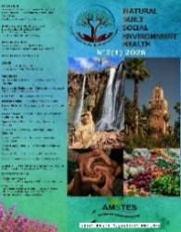

Status and Prospects of Agricultural Development in Western Ukraine

Petro Hnativ ^{1,2,a*} Oleg Stasiv ^{1,b}, Halyna Panahyd ^{1,c}, Hryhoriy Konyk ^{1,d}, Stakh Vovk ^{1,e}

¹ Institute of Agriculture of the Carpathian Region of the National Academy of Agrarian Sciences , Lviv, Ukraine
² Stepan Gzhytskyi National University of Veterinary Medicine and Biotechnologies of Lviv , Lviv, Ukraine

ª ORCID: 0000-0003-2519-3235; Email: pshnativ@ukr.net
^{b} ORCID: 0000-0003-3737-739X; Email: inagrokarpat@gmail.com
^{c} ORCID: 0000-0001-8545-2580; Email: panakhyd-galia@isgkr.science
^{d} ORCID: 0000-0003-2841-2982; Email: grygorii.konyk@gmail.com
^{e} ORCID: 0000-0002-1439-5483; Email: vovkstah@gmail.com

* Corresponding author: Petro Hnativ ; Email: pshnativ@ukr.net

Graphical Abstract
Western Ukraine possesses immense agricultural potential, yet this potential will only be fully realised through the reconstruction and modernization of the livestock sector within a sustainable and scientifically guided framework.

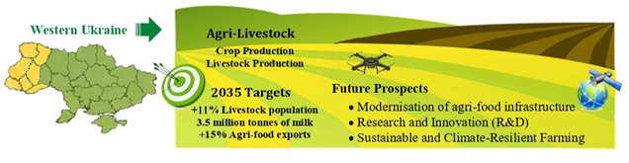

DOI: 10.63095/NBSEH.26.1360049  Received: 04 January 2026  Revised: 24 February 2026  Accepted: 06 March 2026  Published online: 07 April 2026  Citation: Hnativ, P., Stasiv, O., Panahyd, H., Konyk, H., & Vovk, S., 2026, Status and prospects of agricultural development in Western Ukraine. Natural Built Social Environment Health 2(2), 23-34. http://www.doi.org/10.63095/NBSEH.26.1360049 | Abstract: Some 3.6 million people are economically active in the Western region of Ukraine, of whom 840 000 (23 per cent) work in the agricultural sector. By December 2022, 860 900 people had migrated to the Western region following Russia’s military invasion. Given its favourable physical and geographical location, abundant natural and human resources, and an unpolluted environment suited to agricultural development under a warming climate, the Western region of Ukraine is regarded as economically and socially promising. Measures are proposed to set the region on a path towards sustainable, environmentally safe, and intersectorally balanced development of agricultural production and stockbreeding in the short and long term.  Keywords: Natural resources, Agriculture, Livestock.

Introduction
Ukraine has been rightly identified as Europe’s Brazil: an untapped asset and engine of foreign policy in a century troubled by climate change and resource scarcity, which will add 25 per cent of new cropland to the European Union, making it the world’s largest agricultural producer [1]. Western Ukraine – the districts of Volyn, Zakarpattia, Ivano-Frankivsk, Lviv, Rivne, Ternopil and Chernivtsi (Fig. 1) – accounts for 16 per cent of arable land in Ukraine, equivalent to 37 180 km² [2], comparable to the whole of Belgium (30 510 km²) or the Netherlands (41 526 km²). The administrative centre, the city of Lviv, is located at 49°53′53.3″ N and 24°05′15.7″ E.

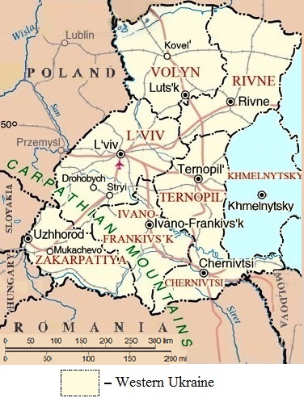

Figure 1. Map of the Western region of Ukraine showing the administrative districts considered in this study [3].

The lowlands of the forest steppe and Ukrainian Polissia enjoy reliable rainfall: hydrothermal coefficients range from 1.0–1.3 (insufficient moisture) to 1.3–1.6 (sufficient moisture); the Carpathian Mountains are more humid (> 1.6) [4].
The soil cover is dominated by sod-podzolic and gleyed soils of low fertility on sandy alluvial and fluvioglacial deposits, and moderate fertility on loess; fertile chernozems on loess occupy smaller areas; soddy and meadow-brown soils are widespread; brown mountain forest and soddy brown soils prevail in the Carpathians [5,6].
Extensive areas require measures to combat water erosion, substantial areas need drainage, and intensive care is required to control water erosion and flash floods in the mountains [7].
The Western region is benefiting from climate warming [8]. The average air temperature at Rivne has increased by 2°C since 1963–1967 (Fig. 2).

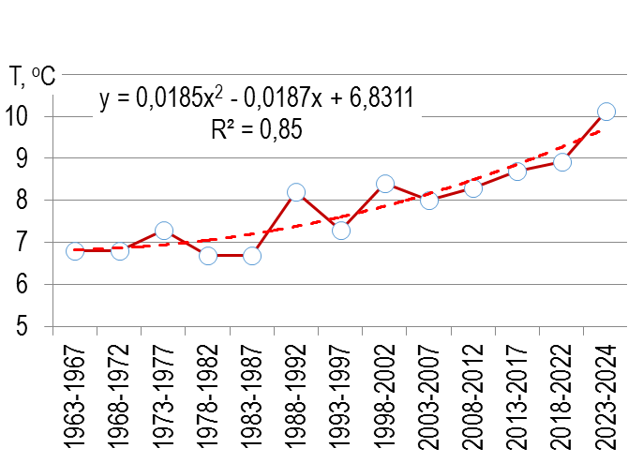
Figure 2. Trend in average annual air temperature (T, °C) at Rivne during 1963–2024

Out of a national population of 41.1 million in December 2022, the population of the Western region amounted to 9.1 million, including 4.7 million rural residents (of whom 840 000 were engaged in the agricultural sector) [9].
According to the Ministry of Social Policy of Ukraine, more than 860 000 people displaced by the Russian invasion have moved to the western districts; the largest numbers have settled in Lviv district (257 000).
As a result, the Western region accounted for 22 per cent of Ukraine’s population, indicating a significant human potential and an urgent need for regional economic development.

Current status of the agricultural sector
Since the pre-war period, particularly since 2021, the sown areas of major arable crops (including winter wheat, maize-for-grain, sunflower and rapeseed) have declined. At the same time, the area under soybean cultivation has increased sharply, taking advantage of rising temperatures [10], and there has been a moderate increase in sugar beet and potatoes. The Western region has also shared a longer-term, nationwide reduction in areas under fodder crops and perennial grasses.
Despite martial law, crop yields have gradually increased both in Ukraine overall and in the Western region [11]. Nationwide, the yield of winter wheat increased to 4.94 t/ha (an increase of 0.1 t/ha in 2024 compared with 2021); in the Western region, average yield increases amounted to 0.66 t/ha for winter wheat, 0.9 t/ha for grain maize, 0.24 t/ha for soybean and sunflower, 0.46 t/ha for rapeseed, 15.14 t/ha for sugar beet, and 5.19 t/ha for potatoes.
These improvements in field productivity have enabled Ukraine to restore rapidly or even increase exports of arable crops [12]. In 2024, wheat exports were worth US$3.73 billion, maize US$5.07 billion, rapeseed US$1.85 billion, and barley US$0.56 billion (Fig. 3).
A critical imbalance has developed between the cropping and livestock sectors. Throughout the period 1990–2023, grain exports have remained in the realms of billions of dollars, yet cattle numbers have halved and imports of milk and dairy products have steadily increased. Since 2022–2023, there has been a sharp uptick in imports of livestock products: imports of beef increased 2.5-fold; imports of lamb and goat meat rose fourfold; imports of live pigs tripled, and imports of live poultry rose by 38 per cent.
In 2024, imports of milk and dairy products reached US$283 million, cheese imports increased to US$227 million, beef imports amounted to US$17 million, and imports of live domestic poultry to US$76 million (Fig. 4).
This dependence on imports of livestock products is not in the national interest, and the meat- and dairy-processing industries of the Western region are operating well below their capacities. Moreover, integration of crops and livestock is essential to maintain soil organic matter stocks.
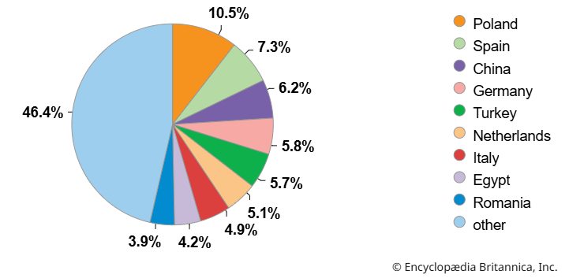
Figure 3. Distribution of Ukrainian agricultural exports by destination country in 2024 [11].

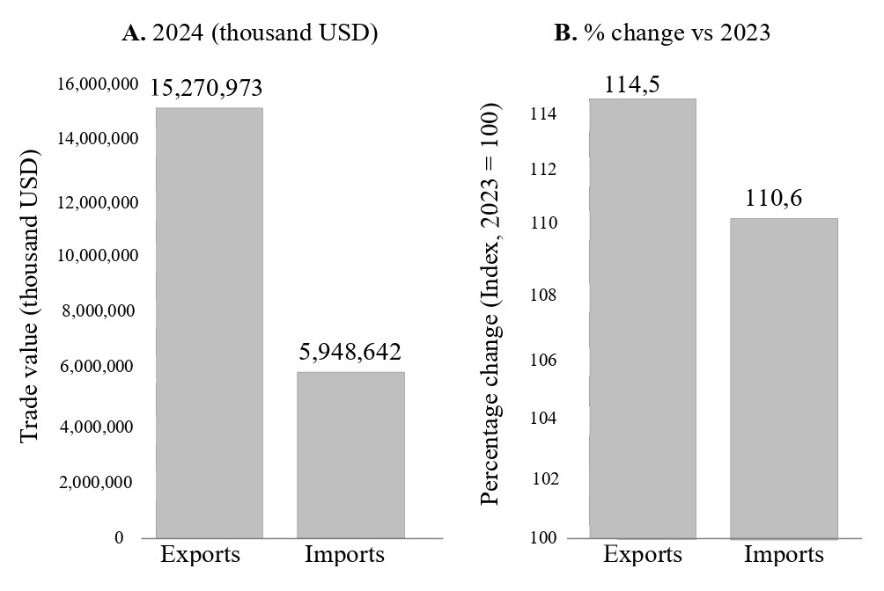
Figure 4. Exports and imports of food and live animals, beverages and tobacco in Ukraine in 2024 (SITC, 2024) and percentage change compared with 2023.

In 2015, the Western region carried 929 000 head of cattle [13]; by 2024, numbers had declined to 498 000. Total milk production fell from 3.04 to 2.25 billion tonnes (–26 per cent) although, during the same period, family farms increased milk sales from 260 000 to 385 000 t.
The structure of meat production has also changed: in 1990, beef accounted for 59 per cent of total meat output; by 2023, pork had become dominant (41 per cent or 233 000 t), followed closely by poultry (40 per cent or 230 000 t). Notwithstanding an increase in the live weight of animals for slaughter, the Western region produced only 93 400 t of beef and 5 500 t of lamb [14].
During 2015–2024, opposing trends emerged in smaller livestock: a significant increase in pig numbers in large agricultural enterprises accompanied a decline in household pigs; an overall reduction in the number of goats and sheep, with a small increase in numbers in larger farm enterprises.
The livestock sector retains substantial potential for development given its lighter environmental footprint compared with the EU: natural pastures, significantly lower application rates of mineral fertilisers and agrochemicals, and the absence of heavy industry [15,16]. Additional advantages include expanding access to EU markets, international investment opportunities, and a favourable location for cross-border cooperation and trade.
The region is well able to produce sufficient fodder: in addition to rotational forage crops on 3.9 million ha of arable land, there are 718 000 ha of hayfields and 1 062 000 ha of pastures. Currently, 490 000 ha is classified as low-productivity forage (degraded hayfields and pastures requiring improvement), a further 80 900 ha as unused land and 36 000 ha as uncultivated fallow, and there are 659 000 ha of underutilised high-mountain meadows.
The meadows and pastures provide 1.3 million feed units, which could be increased by 15–20 per cent, to some 2.4 million feed units, through extension of the area and more intensive management.
War has inevitably curtailed capital investment in the conservation of soil and water resources; countrywide, expenditure declined from UAH 2.7 billion in 2021 to UAH 1.0 billion in 2024, yet the Western region’s share of total and capital expenditure rose from 8 and 5 per cent to 14 and 17 per cent, respectively.
In 2024, total expenditure on research and development by enterprises in Lviv district was UAH 108 million, exceeded only by the city of Kyiv and Dnipropetrovsk district. Annual R&D investment in agricultural and veterinary sciences increased nationwide by nearly UAH 83.5 million between 2021 and 2024, and by UAH 0.833 million in Lviv district.
The number of full-time R&D staff in Ukraine fell from 2 989 in 2021 to 2 944 persons in 2024; in Lviv district it remained at about 200.

Prospects
The Institute of Agriculture of the Carpathian Region of the National Academy of Agrarian Sciences of Ukraine has projected development indicators for the Western region of Ukraine up to 2035. In the livestock sector, compared with 2024, cattle should increase by 41 per cent to 894 000, pigs by 15 per cent to 2.2 million, sheep and goats by 37 per cent to 390 000, poultry by 8 per cent to 44 000, and horses by 17 per cent to 112 000.
The larger dairy herd should increase milk production by 60 per cent to 3.5 million tonnes, with milk yield per cow reaching 6 969 kg, compared with the current level of 6 217 kg. This will mean increased demand for feed.
At present, annual grain requirements amount to 4.2 million tonnes; by 2035, feed-grain production will need to reach 2.7 million tonnes for cattle, 2.4 million tonnes for pigs, 71 000 t for sheep and goats, 28 000 t for horses, and 2 400 t for poultry. In total, 5.2 million tonnes, which will require 747 900 ha under cereals with an average yield of 6.9 t/ha.
At the same time, forage crops should supply 1.7 million tonnes of feed units, and hayfields and pastures should provide another 3 million tonnes.
At present, the meat- and dairy-processing industries of the Western region are operating below capacity: the 46 milk-processing enterprises operate at 78 per cent capacity, processing 634 500 t of milk; 209 meat-processing enterprises operate at 80 per cent capacity, processing 160 500 t.
Enhancing livestock productivity requires the implementation of modern scientific developments. Currently, 62 specialised stockbreeding farms maintain 20 641 pedigree dairy cows. The average productivity of the best Holsteins reaches 10 339 kg of milk per lactation; the Ukrainian Black-and-White dairy breed achieves an average lactation of 7 940 kg.
New varieties of forage and field crops have been introduced, such as the medium-maturing, high-yielding, lodging-resistant spring barley varieties Orvel and Aktual, and oat varieties Artur, Ant, and Andrii [16]; awnless bromegrass variety Karpatskyi, with a dry matter yield of 9.9 t/ha [17], and bird’s-foot trefoil variety Verkhovynets, yielding 7.9 t/ha [18].
Scientific principles for the creation and management of highly productive hayfields and pastures have been developed for sown grasslands on sloping forest-steppe lands of Western Ukraine, yielding 10.5 t/ha of dry matter, and 5.5 t/ha under Pre-Carpathian conditions [16].
Well-grounded approaches to improving soil fertility and soil conservation on sloping lands in the Carpathians are available to reclaim abandoned land. Short crop rotations may achieve grain yields of 4.3–4.7 t/ha and 6.2–7.2 t/ha of feed units; grain–forage rotations yield 5.9–7.0 t/ha of feed units; reduced tillage and intercropping systems can achieve much improved soil and water conservation and increase soil organic carbon stocks [16].
In the livestock sector, recommendations have been developed for housing conditions, microclimate parameters in livestock facilities, nutrition, and genetics that substantially improve animal welfare and product quality.

Despite these advances, livestock farming and processing face an unstable political and economic situation. Production volumes have increased in export-oriented crop production, yet livestock numbers have declined. Livestock require skilled labour and offer only a slow return on investment, and progress is impeded by insufficient state financial support and limited access to affordable credit for small and medium-sized producers. Production is now concentrated in family farms rather than larger agricultural enterprises, although family farms average only 4 636 kg of milk per lactation, compared with 7 463 kg in larger enterprises.
The following needs have been identified following a comprehensive analysis of the current state of agricultural and livestock production, natural challenges, principles of sustainable natural resource management, and in accord with the Law of Ukraine on Priority Areas of Science and Technology Development—development of livestock farming towards modern biotechnologies, reproduction and breeding, and innovative animal housing:
• Improvement of nutrition and forage production
• Adaptation to climate change through the development and adoption of resilient crop and forage varieties
• Enhancement of soil fertility and reduction of nitrate and pesticide pollution and greenhouse gas emissions
• Precision agriculture and agrochemical services to ensure efficient use of natural resources and preservation of diverse ecosystem services of agricultural landscapes
• Diversification of production and innovative crop technologies to support biodiversity, organic farming and forage production
The following are general recommendations for the short, medium, and long term:

Short term (2026–2028):
A livestock-support programme at the level of local communities, ideally through service cooperatives for small producers, offering credit programmes for dairy farming (with interest rates not exceeding 5 per cent), along with grants covering 50 per cent of the cost of young pedigree stock.
Restoration of 100 000 ha of degraded grasslands to a productivity of 4–5 t dry matter/ha and introduction of short rotations with 25–30 per cent forage crops.
Promotion of small farms with capacities of 50–100 cows under tethered housing systems.
The expected outcomes of these measures include a 15 per cent increase in cattle numbers (to 572 000), a 12 per cent increase in milk production (to 2.5 million tonnes), and a 20 per cent reduction in imports of dairy products.

Medium term (by 2030):
Infrastructure development, including modernisation of 20 dairy-processing plants, construction of five regional meat-processing plants, and establishment of a milk collection centre in each district.
Intensified stockbreeding programmes, including expansion of Holstein and Simmental breeding stock; genetic evaluation using the Best Linear Unbiased Prediction method with high-density genetic markers; and establishment of 10 new breeding farms with 300–500 cows each.
An additional 166 000 ha under highly productive grasslands; introduction of legume–grass mixtures in crop rotations on 200 000 ha, and expansion of maize silage to 141 000 ha.
The outcomes should include an increase in cattle numbers to 702 000 head (+41 per cent compared with 2024); milk production reaching 2.7 million tonnes (+19 per cent), beef production increasing to 92 500 t, and meat- and dairy-processing plants operating at 85–90 per cent capacity.

Long term (by 2035):
Systemic transformations, including infrastructure and production–organisational reforms; protected geographical status for regional products; formation of agro-industrial clusters; and promotion and state support of organic produce.
Development and implementation of precision livestock farming systems (sensors, process automation); genomic selection in high-performance herds; and biogas installations at 30 per cent of large farms. Restoration of 229 000 ha of high-mountain meadows, 69 000 ha of degraded lands, and buffer zones along watercourses in the form of 20 000 ha of perennial grassland.
Self-sufficiency of the Western region in milk production is expected to reach 140–150 per cent, exports of cheese and meat products to EU countries will increase, and the annual profitability of dairy farming will reach 35–45 per cent.

Conclusions

The Western region of Ukraine shows substantial untapped potential for balanced agricultural development, including more than one million ha of natural pastures and the possibility of expanding highly productive grasslands by 166 000 ha. Yet, the critical decline of the livestock sector — specifically a 46 per cent reduction in cattle numbers during 2015–2024 — has resulted in the region’s dependence on imports of dairy products exceeding US$280 million annually.
The projections of the Institute of Agriculture of the Carpathian Region of the National Academy of Agrarian Sciences of Ukraine indicate the opportunity of increasing cattle numbers to 894 000 head and milk production to 3.5 million tonnes by 2035, ensuring regional self-sufficiency and creating export potential. The prerequisites include: state economic and organizational support for farmers at the local community level; cooperative stock rearing and crop production; modernization of agricultural product processing; restoration of grasslands and implementation of modern feeding and housing technologies; increased funding for agricultural science and research in crop and stock breeding, industrial seed production, and precision agriculture — all of which are increasingly adopted in EU countries. Based on these priorities, a new research programme of the Institute of Agriculture of the Carpathian Region of the National Academy of Agrarian Sciences of Ukraine for 2026–2030 — entitled Scientific Foundations for the Integrated Development of Agricultural Sectors and Sustainable Management of Regional Resources — is being formulated to promote sustainable agriculture and facilitate Ukraine’s integration into international markets.

Disclosure statement
The authors report no potential conflict of interest.

References
- Keulertz, M., Woertz, E., & Gilmont M., 2024, Europe’s Brazil. How Ukraine could transform Europe’s role in global food supply. International Journal of Environmental Studies 81(1) 169-176. https://doi.org/10.1080/00207233.2024.2313337
- State Statistics Service of Ukraine, 2025, Sown areas of agricultural crops by crop type. https://www.ukrstat.gov.ua/
- Marynych, A., Pashchenko, V., & Shyshchenko, P., 1985, Nature of the Ukrainian SSR: Landscapes and physical-geographical regionalisation (Kyiv: Naukova Dumka)
- Martyn, A., Osypchuk, S., & Chumachenko, O., 2015, Natural–agricultural regionalisation of Ukraine (Kyiv: Comprint)
- Krupskyi, N., & Polupan, N. (eds), 1979, Atlas of soils of the Ukrainian SSR. (Kyiv: Urozhai)
- Ivanyuk, H., Yamelynets, T., Papish, I., Hnativ, P., Pankiv, Z., Bonishko, O., Ivaniuk, V., Haskevych, O., Baranskyi, D., & Avhustynovych, M., 2026, Soil classification of Ukraine and its correlation with WRB (2022). Soil Science Annual 77(1) 215263. https://www.soilsa.com/Issue-1-2026,16385
- Truskavetskyi, R., 2007/2023, Soil-reclamation regionalization. In: Encyclopedia of Modern Ukraine. (Kyiv: Institute of Encyclopedic Research, National Academy of Sciences of Ukraine). https://esu.com.ua/article-25846
- Hnativ, P., & Kachmar O., 2025, Climate fluctuations and weather conditions for crop farming in western Ukraine. Foothill and Mountain Agriculture and Animal Husbandry 77 (1) 41-54. https://doi.org/10.32636/01308521.2025-(77)-1-4
- State Statistics Service of Ukraine, 2022, Employed population by economic activity and region. https://ukrstat.gov.ua/operativ/operativ2013/rp/zn_ed_reg/zn_ed_reg_u/arch_zn_ed_u.htm
- Polovyy, V., Hnativ, P., Balkovskyy, V., Ivaniuk, V., Lahush, N., Shestak, V., Szulc, W., Rutkowska, B., Lukashchuk, L., Lukyanik, M., & Lopotych, N. 2021, The influence of climate changes on crop yields in Western Ukraine. Ukrainian Journal of Ecology 11(1), 384–390. https://doi.org/10.15421/2021_56
- Lykhochvor, V., Hnativ, P., Petrichenko, V., Ivaniuk, V., Lahush, N., Shestak, V., Szulc, W., Rutkowska, B., Lukashchuk, L., Lukyanik, M., & Lopotych, N., 2022, Threat of degradation of agricultural land in Ukraine through a negative balance of nutritional elements in growing of field cultures. Journal of Elementology 27(3), 695-707. https://doi: 10.5601/jelem.2022.27.2.2290
- Encyclopaedia Brittanica, 2024, Ukraine major export destinations. https://www.britannica.com/place/Ukraine/Finance
- Sedilo, G., (eds), 2023, Dairy cattle breeding: breeding, technology, feeding (Obroshyne: IA KR NAAS)
- Stasiv, O. (ed), 2022, Socio-economic models of development of the Carpathian region: economy, livestock (Obroshyne: IA KR NAAS)
- Hnativ, P., & Stasiv, O., 2025, System analysis and agroecosystems (Obroshyne: IА KR NAAS). https://doi.org/10.32636/9786178433079/2
- Bilovus, G., Voloshchuk, I., Hnativ, P., Ivaniuk, V., Lahush, N., Shestak, V., Szulc, W., Rutkowska, B., Lukashchuk, L., Lukyanik, M., & Lopotych, N., 2024, Agroecological foundations of agricultural production of the Western region (Obroshyne: IA KR NAAS).
- Baystruk-Glodan, L., Khomyak, M., Peregrym, O., Hnativ, P., Ivaniuk, V., Lahush, N., Shestak, V., Szulc, W., Rutkowska, B., Lukashchuk, L., Lukyanik, M., & Lopotych, N., 2024, Scientific foundations of selection and seed production of perennial grasses in the Precarpathian region (Obroshyne: IA KR NAAS).
- Karasevich, N., Marcinko, T., Begei, S., & Dziubaylo A., 2025, Ecological and agro-technological aspects of the formation of fodder productivity of perennial sown grasses in the Precarpathian region (Obroshyne: IA KR NAAS).

